**Лабораторная работа №11**

**«Использование MySQL для создания веб-приложения»**

**Index.php**

<!DOCTYPE html>

<html>

  <head>

    <title>Таблица</title>

    <style>

      table {

        border-collapse: collapse;

        width: 100%;

      }

      th,

      td {

        border: 1px solid #ddd;

        padding: 8px;

        text-align: left;

      }

      th {

        background-color: #f2f2f2;

      }

      .delete-button {

        background-color: #f44336;

        color: white;

        border: none;

        padding: 8px 16px;

        text-align: center;

        text-decoration: none;

        display: inline-block;

        font-size: 14px;

        margin: 4px 2px;

        cursor: pointer;

      }

    </style>

  </head>

  <body>

    <h1 align="center">База данных стабилитронов</h1>

    <table>

      <thead>

        <tr>

          <th>Тип корпуса</th>

          <th>Uст ном, В</th>

          <th>T, °С</th>

          <th>Удалить</th>

        </tr>

      </thead>

      <tbody>

      <?php

        $conn = new mysqli("localhost", "root", "mysql", "stabilitrons");

        if ($conn->connect_error) {

            die("Connection failed: " . $conn->connect_error);

        }

        $sql = "SELECT * FROM stab";

        $result = $conn->query($sql);

        if ($result->num_rows > 0) {

            while($row = $result->fetch_assoc()) {

                echo "<tr>";

                echo "<td>" . $row["name"] . "</td>";

                echo "<td>" . $row["voltage"] . "</td>";

                echo "<td>" . $row["temperature"] . "</td>";

                echo "<td><a href='delete.php?id=" . $row["id"] . "'><button class='delete-button'>Удалить</button></a></td>";

                echo "</tr>";

            }

        } else {

            echo "0 results";

        }

        $conn->close();

        ?>

      </tbody>

    </table>

    <br>

    <a href="add.php">Добавить стабилитрон в БД</a>

    </table>

  </body>

</html>

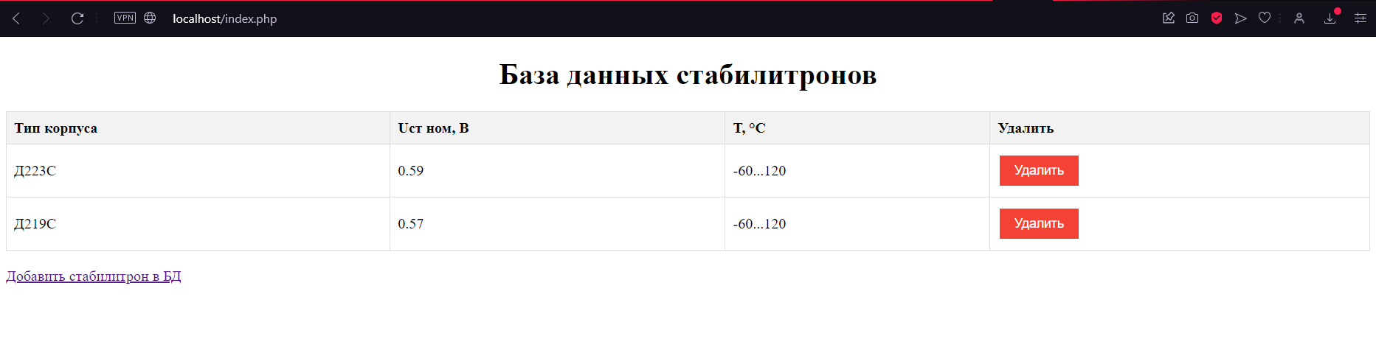

**Add.php**

<!DOCTYPE html>

<html>

<head>

<title>Stabilitrons</title>

    <link rel="preconnect" href="https://fonts.googleapis.com">

    <link rel="preconnect" href="https://fonts.gstatic.com" crossorigin>

    <link href="https://fonts.googleapis.com/css2?family=Barlow&display=swap" rel="stylesheet">

    <link rel="stylesheet" href="style.css">

</head>

<body>

    <h2>Добавить новый стабилитрон</h2>

    <form action="insert.php" method="post">

        <label for="name">Название:</label><br>

        <input type="text" name="name" id="name" required><br><br>

        <label for="voltage">Напряжение:</label><br>

        <input type="text" name="voltage" id="voltage" required><br><br>

        <label for="temperature">Температура:</label><br>

        <textarea name="temperature" id="temperature" required></textarea><br><br>

        <input type="submit" value="добавить">

    </form>

</body>

</html>

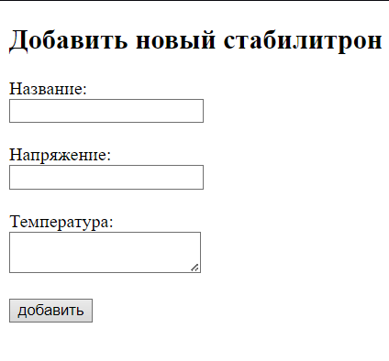

**createdb.php**

<?php

$servername = "localhost";

$username = "root";

$password = "mysql";

$conn = new mysqli($servername, $username, $password);

if ($conn->connect_error) {

    die("Connection failed: " . $conn->connect_error);

}

$sql = "CREATE DATABASE stabilitrons";

if ($conn->query($sql) === TRUE) {

    echo "Создана успешно";

} else {

    echo "Ошибка создания" . $conn->error;

}

$conn->close();

?>



**delete.php**

<?php

$servername = "localhost";

$username = "root";

$password = "mysql";

$dbname = "stabilitrons";

$conn = new mysqli($servername, $username, $password, $dbname);

if ($conn->connect_error) {

    die("Connection failed: " . $conn->connect_error);

}

$id = $_GET["id"];

$sql = "DELETE FROM stab WHERE id=$id";

if ($conn->query($sql) === TRUE) {

    echo "Удаление прошло успешно";

} else {

echo "Ошибка удаления" . $conn->error;

}

header("Location: index.php");

exit;

$conn->close();

?>

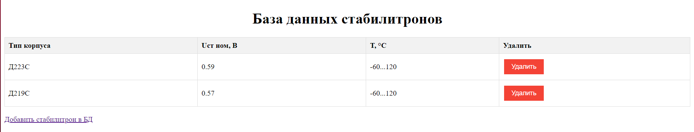

**insert_base.php**

<?php

$servername = "localhost";

$username = "root";

$password = "mysql";

$dbname = "stabilitrons";

$conn = new mysqli($servername, $username, $password, $dbname);

if ($conn->connect_error) {

    die("Connection failed: " . $conn->connect_error);

}

$sql = "INSERT INTO stab (name, voltage, temperature)

VALUES ('Д219С', 0.57, '-60...+120'),

       ('Д220С', 0.59, '-60...+120'),

       ('Д808', 0.59, '-60...+ 125')";

if ($conn->multi_query($sql) === TRUE) {

    echo "Успешно";

} else {

    echo "Ошибка: " . $sql . "<br>" . $conn->error;

}

$conn->close();

?>



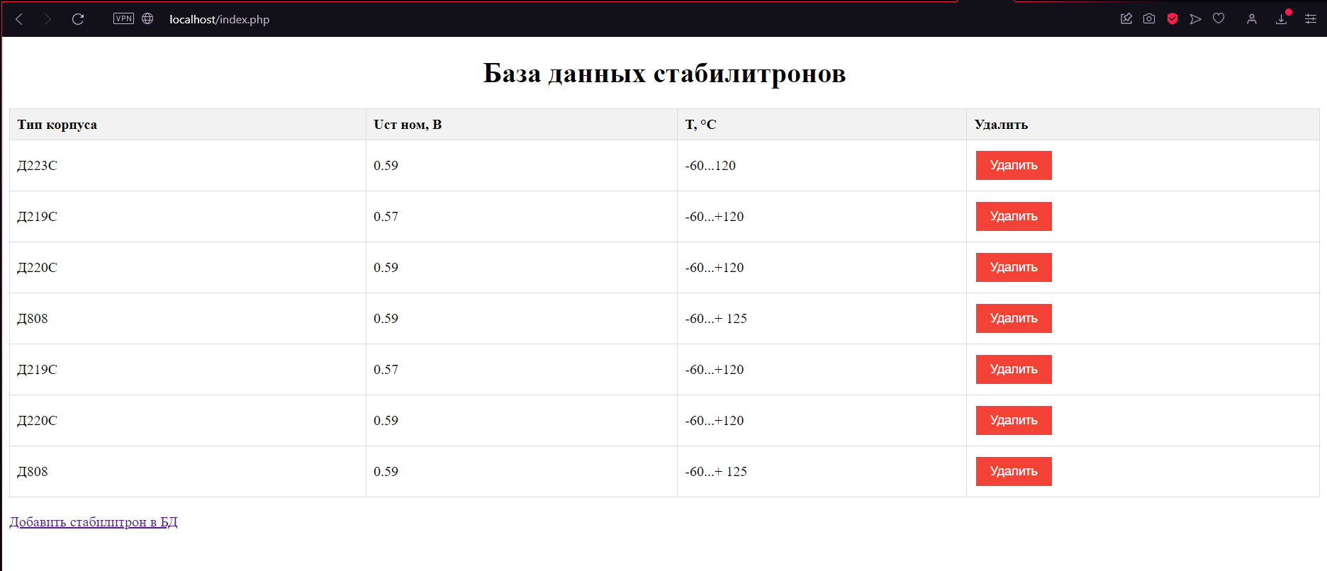

**insert.php**

<?php

$servername = "localhost";

$username = "root";

$password = "mysql";

$dbname = "stabilitrons";

$conn = new mysqli($servername, $username, $password, $dbname);

if ($conn->connect_error) {

    die("Connection failed: " . $conn->connect_error);

}

$name = $_POST["name"];

$voltage = $_POST["voltage"];

$temperature = $_POST["temperature"];

$sql = "INSERT INTO stab (name, voltage, temperature)

VALUES ('$name', '$voltage', '$temperature')";

if ($conn->query($sql) === TRUE) {

    echo "Выполненно без ошибок";

} else {

    echo "Ошибка: " . $sql . "<br>" . $conn->error;

}

header("Location: index.php");

exit;

$conn->close();

?>

**output.php**

<?php

$servername = "localhost";

$username = "root";

$password = "mysql";

$dbname = "stabilitrons";

$conn = new mysqli($servername, $username, $password, $dbname);

if ($conn->connect_error) {

    die("Connection failed: " . $conn->connect_error);

}

$sql = "SELECT id, name, voltage, temperature FROM stab";

$result = $conn->query($sql);

if ($result->num_rows > 0) {

    while($row = $result->fetch_assoc()) {

        echo "" . $row["id"]. " - Name: " . $row["name"]. " - Voltage: " . $row["voltage"]. " - Temperature: " . $row["temperature"]. "<br>";

    }

} else {

    echo "0 Результатов";

}

$conn->close();

?>

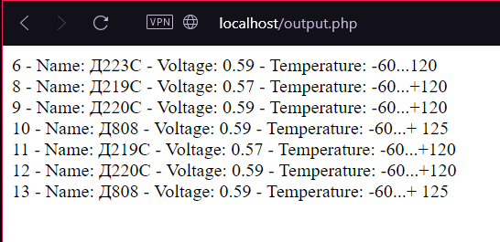

**table.php**

<?php

$servername = "localhost";

$username = "root";

$password = "mysql";

$dbname = "stabilitrons";

$conn = new mysqli($servername, $username, $password, $dbname);

if ($conn->connect_error) {

    die("Connection failed: " . $conn->connect_error);

}

$sql = "CREATE TABLE stab (

id INT(6) UNSIGNED AUTO_INCREMENT PRIMARY KEY,

name VARCHAR(30) NOT NULL,

voltage FLOAT NOT NULL,

temperature VARCHAR(255) NOT NULL

)";

if ($conn->query($sql) === TRUE) {

    echo "Таблица создана успешно";

} else {

    echo "Ошибка создания таблицы" . $conn->error;

}

$conn->close();

?>

